**Projects in Web Systems and Technologies Final Report**

**SE4106**



**Sport Management System**

Group 05

**Department of Software Engineering**

**Faculty of Computing**

**Sabaragamuwa University of Sri Lanka**

**Declaration**

We declare that this thesis does not incorporate, without acknowledgment, any material previously submitted for a Degree or a Diploma in any University, and to the best of our knowledge and belief, it does not contain any material previously published or written by another person or ourself except where due reference is made in the text.

Also, we hereby grant to Sabaragamuwa University of Sri Lanka the non- exclusive right to reproduce and distribute my thesis, in whole or in part in print, electronic or other medium. We retain the right to use this content in whole or part in future works (such as articles or books).

Group 05:

|  |  |  |  |
| --- | --- | --- | --- |
| **Index Number** | **Name** | **Email Address** | **Signature**  **of the Student** |
| 21CSE0159 | M. S. Udara Rathnayaka | msurathnayake@std.foc.sab.ac.lk |  |
| 21CSE0160 | U. A. D. N. Sampath | uadnsampath@std.foc.sab.ac.lk |  |
| 21CSE0161 | P. Kaveesha Sewmini | pksewmini@std.foc.sab.ac.lk |  |

Date: 25st July 2025

**Certificate of Approval**

We hereby declare that this thesis is from the student’s own work and effort, and all other sources of information used have been acknowledged. This thesis has been submitted with our approval.

|  |  |  |  |
| --- | --- | --- | --- |
| **Index Number** | **Full Name** | **Contribution** | **Signature**  **of the Student** |
| 21CSE0159 | M. S. Udara Rathnayaka | Frontend development, database design |  |
| 21CSE0160 | U. A. D. N. Sampath | Frontent development, UI/UX design, Documentation |  |
| 21CSE0161 | P. Kaveesha Sewmini | Backend development, Documentation |  |

Name of Internal Supervisor:

…………………………………… Internal Supervisor

Date: 25th July 2025

…………………………………… Head of the Department

Date:

**Acknowledgment**

We extend our heartfelt gratitude to Mr. H.M.K.T. Gunewardhana, our respected supervisor, for his invaluable guidance, unwavering support, and dedicated supervision throughout the development of our Sports Management Website. His deep expertise, timely feedback, and consistent encouragement were instrumental in overcoming challenges and ensuring the successful completion of this project.

We also express our sincere appreciation to Mrs. W.M.L.S. Abeythunga, our subject lecturer, whose insightful advice and continuous support greatly enhanced our understanding of the subject matter. Her constructive suggestions and academic guidance helped us refine our project and stay aligned with course objectives.

We are equally thankful to all faculty members, technical staff, and fellow students who provided us with essential resources, feedback, and assistance during various phases of the project. Their contributions added great value to our work.

Lastly, we wish to thank our friends and family members for their patience, encouragement, and emotional support. Their belief in our abilities and constant motivation played a vital role in keeping us focused and determined throughout this journey.

Thank you,

Group 05

**Abstract**

**University Sports Management System** addresses the inefficiencies and fragmentation in managing university sports activities and student engagement. The project aims to develop a centralized, web-based platform that streamlines sports management operations while promoting active participation among students. The system enables students to register for events, explore sports teams, connect through a community page, and purchase official sports merchandise via an integrated online store.

Key objectives include building a user-friendly interface for smooth navigation, ensuring centralized access to team details and achievements, and fostering stronger communication within the university sports community. The platform also focuses on enhancing student recognition and creating a digital environment that celebrates sports culture.

By leveraging modern web technologies and community interaction tools, the University Sports Management System seeks to transform how sports are organized, accessed, and celebrated within the university. This initiative aims to create a vibrant, connected, and engaging experience for all students, encouraging long-term participation and pride in university athletic.

Chapter 1: Introduction 10

1.1 Major goals and objectives 10

1.2 Motivation 11

1.3 The scope of the completed project 12

1.3.1 Title 13

1.3.2 Project deliverables 13

1.3.3 Project constraints 13

1.4 The Approach and Assumptions While Carrying Out the Project Work 16

1.4.1 Approach 16

1.4.2 Assumptions 17

1.5 Concise Summary of Major Outcomes 17

Chapter 2: Background 24

Chapter 3: Specification and Design 25

Chapter 4 30

4.1 Illustration of a non-standard or innovative way of implementing an algorithm and data structure 30

4.1 Difficulties involving existing software 30

4.2 Lack of appropriate supporting software 30

4.3 Over-ambitious project aims 30

Chapter 5: Results and Evaluation 35

5.1 The comparison of experimental results with expected values 36

5.2 Description of the interrelationship of the experimental results 40

User Registration and Profile Management 40

Team and Community Engagement 40

Interlinked System Flow 40

Interrelationship and Impact on User Experience 41

1. User Engagement and Community Post Creation 41

2. Profile Management and Content Visibility 41

3. Team Listings and Sports Networking 41

5.3 Analyze and state the achieved accuracy 42

5.3.1 Quantitative Analysis 42

5.3.2 Qualitative Assessment 43

5.4 Analyze and state implications or limitations 43

5.4.1 Implications 44

5.4.1.1 Enhanced User Experience and Engagement 44

5.4.1.2 Scalable Foundation for Feature Expansion 44

5.4.2 Limitations 45

5.4.2.1 Lack of Mobile Accessibility 45

5.4.2.2 Absence of Secure Payment Integration 45

5.4.2.3 No Integrated Feedback System 45

Chapter 6: Future Work 46

Mobile App Development 46

Payment Integration 46

Social Media Sharing 46

Performance Analytics 46

6.1 Gaps of the project 46

• User Feedback Mechanism 47

• Enhanced Security Measures 47

• Accessibility Improvements 47

6.2 Proposal for enhancement or re-design 48

6.2.1. Mobile App Development 48

Plan 48

6.2.2. Payment Integration 49

Plan 49

6.2.3. Social Media Sharing 49

Plan 49

6.2.4. Performance Analytics 50

Plan 50

Plan 50

Chapter 7: Conclusions 51

7.1 The importance of the result 51

7.2 Validity of the result 52

7.3 Gaps and limitations of the findings 52

Security Enhancements Needed 53

Accessibility Limitations 53

Limited Scalability and Performance Testing 53

No Mobile App Version 53

Integration with University Systems 53

Secure Payment Integration 54

• Accessibility 57

• Security 58

• Scalability 60

• Performance 60

• Reliability 61

**Table of figures**

Figure 1: Gantt chart 15

Figure 2: Use Case Diagram for Sport Management System 25

Figure 3: Entity Relationship Diagram for Sport Management System 26

# Chapter 1: Introduction

In recent years, the role of sports within educational institutions has transcended beyond mere physical activities. Sports foster teamwork, discipline, health, and social engagement among students, contributing significantly to their overall development. Universities worldwide recognize that efficient management of sports activities is vital to maximizing participation, organizing competitive events, and supporting athlete development. However, many institutions continue to rely on traditional, manual, and fragmented methods for managing sports-related operations, resulting in operational inefficiencies, communication gaps, and reduced student engagement.

Specifically, at the Sabaragamuwa University of Sri Lanka, the current sports management environment faces multiple challenges. Sports coordinators and administration staff handle registrations, team formation, event scheduling, merchandise sales, and communication through conventional paper-based or siloed digital approaches. This not only slows down operational workflows but also restricts access, transparency, and effective collaboration among participants, coaches, and managers.

With the advancement of web technologies and the growing trend of digital transformation in education sectors, there is a clear opportunity to innovate how university sports management functions. A comprehensive, scalable, and user-friendly web platform can centralize diverse sports management activities, reduce administrative burden, and enhance the overall experience for users. This underscores the motivation and relevance of the Sports Management System project.

## Major goals and objectives

The major goals of the Sports Management System project are to harness modern web technologies to enhance the coordination, engagement, and operational efficiency of university sports activities. Specifically, the project aims to:

* Centralize sports management by providing a unified platform for registration, team coordination, and communication.
* Improve student participation and interaction with campus sports by offering easy access to information, community engagement features, and online registrations.
* Streamline administrative tasks such as team management, merchandise inventory, and event coordination to alleviate manual workflows and reduce errors.
* Enable a dynamic community environment through features like posts, reactions, and discussion forums centered on university sports.
* Facilitate online merchandise sales, handling inventory and orders via an integrated store to support sports funding and accessibility.

Objectives in Detail:

* Develop a user-friendly registration module that allows students to sign up for sports events easily.
* Implement team management tools for coaches and admins, enabling team creation, member assignment, and schedule coordination.
* Create a community page where students and staff can post updates, share achievements, and interact on sports-related matters.
* Build an online store for sports merchandise, complete with stock tracking and order processing.
* Admin panel development providing role-based access control and efficient management of users, teams, posts, and store inventory.

These objectives collectively aim to create a robust platform that can significantly elevate the sport culture at the university while harnessing technology to reduce administrative overhead.

## Motivation

The motivation behind developing the Sports Management System stems from the noticeable gaps and challenges currently faced in managing university sports activities at Sabaragamuwa University and similar institutions:

* Lack of Centralization: Currently, sports-related data and operations are handled manually or through fragmented systems. This leads to inefficiencies, data discrepancies, and miscommunications.
* Communication Gaps: Students and staff find it difficult to stay updated with the latest sports events, team selections, and community activities, reducing overall involvement.
* Limited Accessibility: Important information about team membership, match schedules, and merchandise availability is often not readily accessible, creating barriers for enthusiastic participants.
* Manual Administrative Work: Coaches and sports coordinators spend considerable time handling paperwork for registrations, managing teams, and coordinating events manually.
* Growing Demand for Online Solutions: With the increasing digitalization of campus activities, a modern web-based solution aligns with user expectations and leverages technology to outperform traditional management methods.
* Addressing these pain points motivates the formation of a centralized, efficient, and interactive platform that benefits students, staff, coaches, and administrators alike, thereby fostering a more vibrant and well-managed sports community

## The scope of the completed project

The scope defines the boundaries and functionalities included within the Sports Management System at the end of this project phase:

Included Features and Modules:

* Student Registration Module: Enables new users to create accounts and enroll in sports activities online.
* User Profile Management: Allows users to create and update personal profiles related to their sports engagement.
* Team Management Module: Provides coaches and administrators with tools to create teams, assign members, manage rosters, and view team information.
* Community Page: A social interaction hub for posting news, achievements, and other sports-related content with comment and reaction features.
* Online Store: Facilitates browsing, ordering, and purchasing sports merchandise with real-time inventory management and order tracking.
* Administrator Panel: Allows the management of users, teams, posts, and store items, incl. adding new coaches and administrative roles.

Out of Scope:

* Mobile Application Version: While planned as a future enhancement, no mobile app development will be conducted during this phase.
* Online Payment Gateway: Payment integration is deferred to future phases; the current store implementation focuses on catalog and order management only.
* Advanced Analytics and AI: In-depth data analytics and AI-driven performance predictions are conceptual features for later development stages.

System Boundaries:

The system primarily serves students, coaches, and administrative staff of the university sports department with online access via standard web browsers. It is designed to handle typical web traffic from a university campus population using standard client-server architecture.

This scoped approach ensures deliverance of a functional and stable system encompassing the core requirements within the stipulated academic project timeline.

### 1.3.1 Title

University Sport Management System

### 1.3.2 Project deliverables

At the conclusion of the project, the team commits to delivering the following concrete outputs:

Fully Functional Web-Based Sports Management Platform consisting of:

* Registration and Login Interfaces - User Profile and Dashboard management
* Team management interfaces for coaches and administrators
* Community feed module supporting posts, comments, and reactions Online merchandise store with catalog browsing, cart management, and order placement
* Administrator panel with tools for managing users, teams, community posts, and store inventory
* Technical Documentation detailing system architecture, database schema, use case diagrams, data flow diagrams (DFDs), entity-relationship (ER) diagrams, and implementation notes.
* Source Code Repository hosted on GitHub, including backend (Laravel-based PHP code), frontend (HTML, CSS, Bootstrap 5), and database scripts (MySQL).
* Test Suites and Test Cases encompassing unit, functional, and usability tests with recorded results to demonstrate system robustness.
* User Manual and Deployment Guide to assist future users and administrators in operating and maintaining the system.
* Demonstration and Presentation Materials showcasing system features and workflows to stakeholders and evaluators.

These deliverables wrap together both the software and the supporting artefacts required to illustrate the project's viability and usability.

### 1.3.3 Project constraints

The project team encountered several constraints that influenced the development process, scope, and final deliverables:

* Time Constraints: The project is bounded by the academic semester timeline, limiting the extent of feature development and extensive testing cycles.

*t*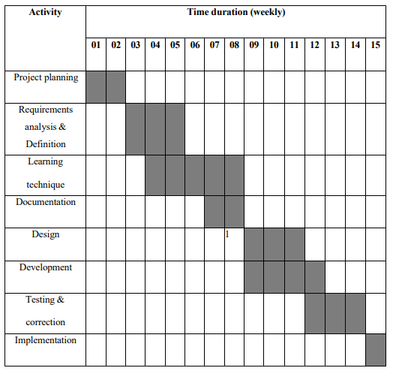

Figure 1: Gantt chart

* Resource Availability: Limited access to specialized hardware and testing environments beyond standard university labs constrained performance and stress testing.
* Technical Expertise: The team’s familiarity primarily with Laravel, basic front-end technologies, and MySQL influenced technology choices and architectural decisions.
* Budget: As a student project, there is no dedicated budget for third-party paid services such as online payment gateways or advanced cloud hosting solutions. The solution relies on open-source technologies.
* Scope Limitations: To ensure feasibility, some ambitious future features (mobile app, AI analytics) were intentionally excluded from this phase.
* User Base: The initial system targets only internal university users, without multi-institution scalability or external public access design considerations at this stage.

Despite these constraints, the project scope remained sufficient to build a meaningful and practical system aligned with university sports management needs.

## The Approach and Assumptions While Carrying Out the Project Work

### Approach

The project followed an Agile development methodology emphasizing iterative progress through planned sprints and continuous feedback incorporation. This approach was chosen due to:

* The evolving nature of user requirements and refinements after each demonstration.
* Enhanced communication within the team and with supervisors to adapt plans dynamically.
* Incremental development allows core functionalities to be implemented and tested early, mitigating risks.
* Incorporation of frequent feedback from students and staff during mock demos to ensure user-centric design decisions.

Key steps in the approach included:

* Requirements gathering through initial discussions and document analysis.
* System design modeled via use case diagrams, ER diagrams, and data flow diagrams.
* Backend development with Laravel framework focusing on robustness and security.
* UI/UX design using HTML, CSS, and Bootstrap to enhance usability.
* Database design using MySQL for persistent, structured data management.
* Testing covering unit, functional, and usability aspects to ensure quality.
* Regular presentations and demonstrations for stakeholder engagement.

This structured but flexible approach aimed to deliver a functional, maintainable, and user-friendly sports management system within the project time frame.

### Assumptions

Certain assumptions were made to define clear boundaries and simplify the development:

* All users (students, coaches, admins) have reliable web access and basic digital literacy.
* User roles and permissions reflect the standard university sports organizational structure.
* The system environment will be hosted on standard client-server architecture with sufficient server resources.
* The merchandise store does not handle payment processing or delivery logistics during this phase.
* Data input by users is assumed to be honest and within defined validation parameters to reduce error scenarios.
* Feedback collected during mock demos represents the majority user perspective for guiding system features.
* The university sports department will provide necessary support for deployment and user onboarding.

These assumptions allowed the team to focus on core functional requirements without over-complicating the implementation.

## Concise Summary of Major Outcomes

The Sports Management System project culminated in several significant outcomes aligned with the initial goals:

* Developed a centralized platform that successfully consolidates sports registrations, team coordination, and community engagement, drastically improving the operational workflow compared to manual processes.
* Implemented a responsive web interface enabling students and staff seamless interaction, visible through modules such as registration, team lists, community feeds, and online store.
* Enhanced administrative control with a dedicated admin panel simplifying user, team, and inventory management, thereby reducing the administrative burden.
* Validated system robustness via comprehensive testing including unit, functional, and usability tests, ensuring system reliability under various scenarios.
* Received positive stakeholder feedback during mock demonstrations, confirming improved engagement and satisfaction among student and staff users.
* Laid groundwork for future expansion with proposed features like mobile app development, payment integrations, and AI analytics firmly in scope for subsequent phases.

In conclusion, the project demonstrates a successful application of modern web technologies to meet the needs of university sports management, fostering better student involvement and streamlined administrative processes.

### 

## 

### 

# Chapter 2: Background

Sports hold great significance in university environments as they contribute not only to physical health but also to fostering community spirit, leadership skills, teamwork, and the overall holistic development of students. Effectively managing sports activities, events, and resources within universities is, however, a challenging task. Many institutions, including Sabaragamuwa University of Sri Lanka, continue to manage their sports programs through manual processes or basic digital tools. This often results in fragmented workflows, inefficient communication between students, coaches, and sports administrators, and difficulties in maintaining data consistency.

In most cases, registrations, event scheduling, team formation, and management of sports merchandise are handled using paper forms, emails, or decentralized spreadsheets. These methods complicate accessibility, hinder transparency, and increase the administrative workload. Such fragmented management practices often lead to delays, communication gaps, and inefficient use of resources, negatively impacting the overall sports culture and student participation.

Recognizing these challenges, there is a strong need to adopt an integrated digital system designed specifically for university sports management. A web-based Sports Management System can unify multiple administrative functions into a single platform, enabling efficient and real-time management of registrations, team coordination, event scheduling, and inventory control. The system also has the potential to facilitate community engagement through interactive features such as news posting, achievement sharing, and discussions. By automating routine tasks and providing administrators with comprehensive dashboards, the platform can significantly reduce manual effort, minimize errors, and provide data-driven insights to improve decision-making.

The shift towards such centralized digital solutions aligns well with modern trends in higher education that aim to enhance both academic and extracurricular experiences through technology. For universities like Sabaragamuwa, implementing a robust Sports Management System supports greater student involvement by improving access and visibility of sports activities. It also enhances the efficiency of sports administrators, optimizes resource allocation, and helps build a connected sports community through sustained communication and collaboration.

Overall, integrating a web-based system for sports management addresses many of the inefficiencies faced by universities today. It contributes to promoting a vibrant, well-organized, and inclusive sports culture consistent with the institution’s broader mission of fostering student development beyond the classroom and strengthening its reputation through successful extracurricular programs.

# Chapter 3: Specification and Design

* 1. **Use case diagram**

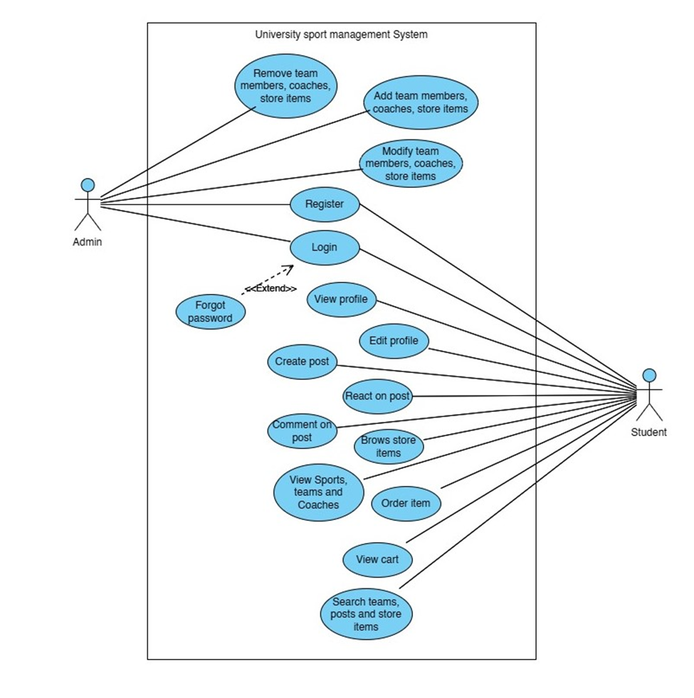The Use Case Diagram of the University Sports Management System shows two main users: **Admin** and **Student**. Admins can register, log in, manage team members, coaches, and store items by adding, modifying, or removing them. Students can register, log in, manage their profile, create posts, react or comment on posts, view sports and coaches, browse and order store items, and search content. A special **"Forgot Password"** option is available as an extension of the login process. This diagram clearly explains what actions each user can perform in the system.

Figure 2: Use Case Diagram for Sport Management System

* 1. **ER diagrams**

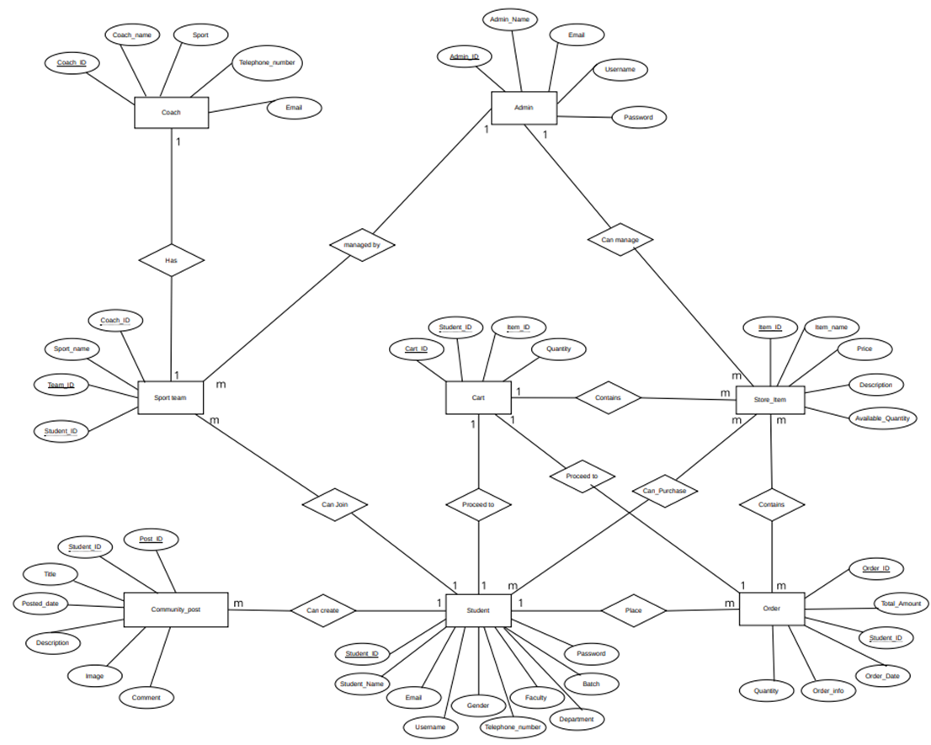The Entity Relationship (ER) Diagram of the University Sports Management System shows how data is organized and how different entities are connected in the database. Key entities include **Student**, **Coach**, **Sport_Team**, **Admin**, **Community_Post**, **Store_Item**, **Cart**, and **Order**. Each entity has its own attributes such as student ID, coach name, team ID, item price, and order details. Relationships between entities (e.g., students making orders or posts linked to profiles) help define how the system stores and manages information effectively.

Figure 3: Entity Relationship Diagram for Sport Management System

* 1. **Sequence diagrams**
  2. **State charts**

**Hardware Requirements**

The hardware requirements for the University Sports Management System ensure smooth performance, reliability, and accessibility for both server and client devices. The system is designed to run on a powerful server with sufficient memory and storage, while supporting access from desktops, laptops, and mobile devices used by students, admins, and coaches. Proper networking equipment is also needed to maintain stable and fast connections within the university environment.

## Chapter 4

## 4.1 Illustration of a non-standard or innovative way of implementing an algorithm and data structure

In the University Sports Management System, an innovative approach can be seen in how **community posts** and **user interactions** are handled. Instead of using a standard flat structure to store posts, the system could implement a **linked or relational data structure** where each post is connected to the student profile, and reactions or comments are stored as related records. This allows dynamic content loading (e.g., latest posts with comments) using efficient **timestamp-based retrieval**, ensuring smooth performance. While this is not explicitly mentioned in the report, the design of the database tables like Community_Post, linked with Student_ID, and the retrieval procedure for displaying posts (as mentioned on page 12), reflects a more organized and scalable method than a basic structure, enabling real-time engagement in the sports community page.

## Difficulties involving existing software

The existing system for managing university sports activities lacks a centralized and user-friendly software solution. As highlighted in the proposal, there is no proper platform for students to register for teams, share achievements, or order sports items online. Communication between students, coaches, and administrators is manual and unorganized, making it difficult to manage teams or track updates. Due to these limitations, the new web-based system is proposed to overcome the inefficiencies of existing methods and provide a more efficient, accessible, and interactive platform for all stakeholders.

## Lack of appropriate supporting software

Currently, there is a lack of appropriate supporting software to manage university sports activities in an organized and efficient way. As mentioned in the proposal, important functions such as team registration, player coordination, event announcements, and ordering sports items are either done manually or through disconnected systems. There is no single platform that supports all user needs like student registration, profile management, community interaction, and store management. This gap in supporting software makes it difficult for students, coaches, and administrators to collaborate effectively. The proposed University Sports Management System aims to fill this gap by providing a centralized, user-friendly web application that integrates all these essential functions.

## Over-ambitious project aims

The proposed University Sports Management System includes several future enhancements such as integrating social media sharing, developing a mobile application, and implementing a secure online payment gateway. While these features add significant value, including them in the early stages could make the project over-ambitious considering limited time and resources. As mentioned in the objectives (Page 6) and methodology sections (Page 24–25), these advanced features are planned for later stages to ensure the core functionalities are completed successfully first. This step-by-step approach helps avoid making the project too large or difficult to manage during the initial development phase.

## 

## 

# Chapter 5: Results and Evaluation

This chapter presents the results and evaluation of the University Sports Management System, highlighting the performance of key functionalities and assessing how well the system meets its intended objectives. The goal is to provide a clear overview of how the implemented features function in real use scenarios and how effectively they support users such as students, team managers, and administrators.

The system was evaluated through a combination of internal testing. Functionalities such as user registration, team creation, the community page, item listing in the online store, and administrative controls were tested to ensure they operate as expected. Each module was tested against its intended purpose to identify whether it meets the usability, reliability, and responsiveness targets set at the design stage.

The testing process confirmed that the platform allows users to register and log in securely, form and manage teams, browse and post in the community section, and view and search for store items efficiently. Admin-specific features such as user management and post moderation also functioned correctly during evaluation.

Despite these positive outcomes, the evaluation also highlighted a few limitations, including the absence of advanced analytics, no mobile version available, and there is no integrated payment gateway. These issues, while not critical, suggest areas for future enhancement.

The results demonstrate that the system largely achieves its intended purpose of managing sports-related activities and content within a university setting. The evaluation confirms the system’s usability and reliability in handling core tasks while also identifying improvement opportunities to strengthen future iterations.

## The comparison of experimental results with expected values

|  |  |
| --- | --- |
| Test Case 1: Student registration with valid data | |
| * Navigate to the system's **registration page**. * Enter valid student details. * Click the **"Register"** button. * The system processes the input and creates a new user account. | |
| Expected Result | The system registers the student successfully. |
| Experimental Result | The student account was created successfully. |

*Table 3: Test Case*

|  |  |
| --- | --- |
| Test Case 2: Confirm password validation when user registration. | |
| * Navigate to the **registration page**. * Enter valid registration details, and enter password and confirm password. * Click the **"Register"** button. * System checks whether the **password** and **confirm password** match. | |
| Expected Result | The system displays an error message: **"Passwords do not match.", if the passwords does not match.**  The registration process is halted.  User stays on the registration page with the form highlighted. |
| Experimental Result | System correctly identified that the passwords did not match.  Displayed error message: **"Passwords do not match."**  User was not registered. |

*Table 4: Test Case 2*

|  |  |
| --- | --- |
| Test Case 3: User Login with an incorrect password. | |
| * Navigate to the **login page**. * Enter the following credentials, email and password. * Click the **"Login"** button. * System checks the credentials against stored user records. | |
| Expected Result | Display an error message: **"Invalid email or password."**  User is **not redirected** to the home page.  Login form is remains for correction. |
| Experimental Result | System displayed: **"Invalid email or password."**  User was not allowed to log in.  Login page remained active for retry. |

*Table 5: Test Case 3*

|  |  |
| --- | --- |
| Test case 4: Show an error when posting a post without a description. | |
| * Navigate to the **“Community”** page. * Leave the **“Description”** field empty. * Fill in the other required fields (e.g., Image or video.). * Click the **“Post”** button. * System validates the form inputs. | |
| Expected Result | Display an error message: **"This field is required."**  Post is **not submitted**.  User remains on the same page to correct the input. |
| Experimental Result | System displayed: **"The title field is required."**  Post was not submitted.  Page remained for corrections. |

*Table 6: Test case 4*

|  |  |
| --- | --- |
| Test Case 5: Show an alert message when an admin delete, update or remove any data. | |
| Login to the system as an **Admin**.  Navigate to a section such as **Users, Posts, Store, Latest news or Teams**.  Perform one of the following actions:   * Click the **Delete** button on an item. * Click the **Update** or **Edit** button, modify the data, and submit.   Observe the system response | |
| Expected Result | System displays a clear **alert/confirmation message** (e.g., "Are you sure you want to delete this?" before deletion).  After the action, a success alert like **"Data deleted successfully"** or **"Update completed"** should appear.  Data is updated or deleted accordingly. |
| Experimental Result | Alert confirmation message appeared before deletion.  Success message displayed after update/delete.  Data changes reflected immediately. |

*Table 7: Test Case 5*

|  |  |
| --- | --- |
| Test Case 6: Show a success message when admin update or insert data into the system. | |
| Log in to the system using valid **Admin credentials**.  Navigate to a section such as:   * **Add New item** * **Create New Team** * **Add latest news** * **Update Existing items, team details and latest news**   Fill in valid details in the input form.  Click the **Update** button.  Observe the response from the system. | |
| Expected Result | A **success message** ( "Data added successfully") should be displayed on the screen.  The newly added or updated data should appear in the respective list or table. |
| Experimental Result | The system showed a message: "Data added successfully" after inserting.  When updated, message displayed: "Update successful".  Data was correctly added and visible. |

*Table 8: Test Case 6*

|  |  |
| --- | --- |
| Test Case 7: Show a success message when user update their profile details. | |
| Log in to the system using valid **User credentials**.  Navigate to the **"Edit Profile"** section.  Modify one or more fields (e.g., name, email, phone number, profile image).  Click the **"Update Profile"** button.  Observe the system's response after submission. | |
| Expected Result | A **success message** such as **"Profile updated successfully"** should be displayed.  Updated profile details should be reflected immediately or after page refresh. |
| Experimental Result | Message displayed: **"Your profile has been updated successfully."**  All changes were saved and visible in the profile. |

*Table 9: Test Case 7*

## 5.2 Description of the interrelationship of the experimental results

The various functionalities within the Sports Management System (SMS) are interconnected, particularly between user actions such as registration, profile management, team interaction, and community participation. These interrelationships ensure a smooth flow of information and foster a collaborative sports environment.

#### User Registration and Profile Management

The registration process in the Sports Management System is the gateway to all other system functionalities. A successful registration allows users to access personalized features of the platform. Once registered, users can manage their profile information, such as full name, email, contact number, faculty, department, batch and gender. Profile management ensures that personal data remain accurate and up to date. These profiles are essential in team formation and communication processes.

#### Team and Community Engagement

Team creation and member management are directly controlled by the administrators. Once logged in, administrators can create new teams, add members, and manage team details. This data is then reflected in the team listing page.

The community page is another area that builds upon user registration and profile details. Registered users can create posts to share announcements, match updates, or general discussions. These posts are displayed with the user's name and profile image, fostering a sense of identity and accountability in the community.

#### Interlinked System Flow

* A user must first register to access profile editing and post creation.
* Only registered users can access team details, store items and contribute to the community page.
* Profile data is dynamically linked to posts and team pages for consistent display.
* Admin activities like approving teams or deleting posts rely on the user and post data structure.

This interconnected system ensures that each function supports the next, creating a smooth and efficient user experience. It highlights how a well-designed flow — from registration to active participation — can enhance engagement in a sports management environment.

#### Interrelationship and Impact on User Experience

###### User Engagement and Community Post Creation

* The ability to create posts is directly linked to the user’s registration status. A simple and efficient registration process encourages more users to join the platform and interact with others.
* User-generated content such as team details highlights enhances the activity and usefulness of the platform. This leads to increase content and boosts user interaction, which encourages more participation and content sharing.

###### Profile Management and Content Visibility

* Accurate and updated user profiles (with details such as name, email, contact number, faculty, department, batch and gender) add trust and clarity to the content shared across the platform. Users are more likely to interact with posts when they can see the identity and background of the person who shared it.
* Editable profile features also allow users to maintain up-to-date information, such as updating achievements. This helps users stay relevant and engaged in the platform's activities, strengthening their personal and team presence.

###### Team Listings and Sports Networking

* Team creation and player listings is done by administrators. Coaches, team leaders, and admins use this data to manage team rosters, and assign roles.
* These listings not only support organizational needs but also encourage inter-team collaboration and networking among players from different departments or universities. It builds a sense of belonging and competitiveness while maintaining a supportive sports community.

The interrelationship between user registration, profile management, team functionalities, and content sharing is central to the success of the Sports Management System. A frictionless registration process kick starts user participation. Robust profile management ensures up-to-date and accurate representation of users. This interconnected flow contributes to a lively, reliable, and engaging environment that enhances the overall user experience and promotes the continuous growth of the sports community.

## Analyze and state the achieved accuracy

In this section, we evaluate the performance of the implemented features within the **Sports Management System**. Using test cases and validation techniques, we assess how accurately core functionalities such as user registration, login, profile updates, team management, and post creation perform as intended. This analysis offers meaningful insights into the system’s reliability, identifying both its strong points and any functional gaps. It helps ensure the platform delivers a smooth and consistent experience for all users along with administrators and highlights areas that may require further refinement for optimal performance.

### Quantitative Analysis

|  |  |  |
| --- | --- | --- |
| Feature | Accuracy | Expected Outcome |
| User registration accuracy | 100% of users who attempted to register successfully created an  account. | Met expected outcome |
| User login accuracy | 100% of users who attempted to log in successfully accessed the home page. | Met expected outcome |
| Profile update accuracy | 100% of users who attempted to update their profile successfully did so. | Met expected outcome |
| Team creation accuracy | 100% of attempts to create a team successfully created it. | Met expected outcome |
| Post creation accuracy | 100% of users who attempted to create a post successfully displayed it. | Met expected outcome |
| Admin action accuracy | 100% of admin actions (add/update/delete) were executed successfully. | Met expected outcome |

*Table 8: Feature Accuracy and Expected Outcomes for Sport Management System*

### Qualitative Assessment

The internal testing conducted on the Sports Management System demonstrated that the user registration and login processes were intuitive, fast, and free from errors, providing a seamless onboarding experience. Profile management and community features functioned smoothly, enabling users to update their personal and sports-related post effectively. These features played a vital role in ensuring personalized and relevant user interactions across the platform.

The system’s post creation, team management, and admin functionalities were also rigorously tested, confirming their accuracy and usability. Users were able to create posts, manage team members, and perform admin-level actions without encountering functional issues, ensuring a streamlined experience for both regular users and administrators.

These results validate the effectiveness and reliability of the SMS platform. The overall usability and consistent accuracy in performing core operations reflect a user-centric and performance-oriented design. This fosters trust among users and enhances satisfaction, confirming that the system is well-suited for managing university sports activities in an organized and efficient manner.

## Analyze and state implications or limitations

In the "Analyzing and Stating Implications or Limitations" section, we critically assess the outcomes of the Sports Management System (SMS) project by identifying its successes, areas for improvement, and existing limitations. This evaluation helps us understand how effectively the system supports user interaction, sports coordination, and administrative functionalities, while also highlighting challenges and future considerations for development.

### Implications

#### Enhanced User Experience and Engagement

The successful implementation of user registration, profile management, and post creation features has significantly improved user experience. Students and sports coordinators can now easily access, update, and manage their information, fostering stronger engagement within the system.

#### Scalable Foundation for Feature Expansion

By accurately developing and testing core features like posting, profile editing, and admin control, the project has established a strong foundation for future growth. Planned features such as community interaction (likes, social media sharing), mobile version development, payement gateway integration and real-time notifications can be built on top of the current system to further enhance functionality and user satisfaction.

### Limitations

#### Lack of Mobile Accessibility

Currently, the system is limited to desktop and browser access, which restricts user interaction on-the-go. Without a dedicated mobile application, students and staff may find it inconvenient to access timely updates, event notifications, or participate in community features while away from their computers.

#### Absence of Secure Payment Integration

The merchandise store does not yet support online transactions, requiring users to rely on manual or in-person payments. This limitation reduces the convenience and scalability of the store, especially for users who prefer digital payment methods.

#### No Integrated Feedback System

The platform currently lacks a structured feedback mechanism, such as reviews, ratings, or surveys. This makes it difficult to collect user input systematically, which could otherwise help in identifying user concerns, measuring satisfaction, and guiding future improvements.

* **Limited Accessibility for Users with Disabilities**

The current interface does not fully address accessibility needs. Users with visual or motor impairments may face difficulties navigating the system due to the lack of features like screen reader support, keyboard navigation, high-contrast mode, or text resizing.

* **Security Gaps in User Data Protection**

While the system uses basic authentication for login, more advanced security practices such as two-factor authentication (2FA) and robust data encryption have not yet been implemented. This poses potential risks when handling sensitive information such as login credentials or merchandise purchase history.

# Chapter 6: Future Work

To enhance the functionality and user experience of the **University Sports Management System**, several future improvements are planned. These enhancements aim to increase accessibility, engagement, and usefulness of the platform for students, staff, and administrators.

#### Mobile App Development

To improve accessibility and convenience, developing dedicated **Android and iOS mobile applications** is a key future goal. A mobile app will enable users to access features such as team updates, community posts, event notifications, and store purchases anytime, anywhere, promoting higher student engagement and real-time interaction.

#### Payment Integration

Integrating a **secure online payment system** is essential for enabling smooth transactions in the platform’s merchandise store. Features like card payments and mobile banking can enhance the user experience while ensuring security and compliance with financial standards.

#### Social Media Sharing

Introducing **social media sharing options** will allow users to post achievements, team victories, and personal milestones directly to platforms like **Facebook, Instagram, or X (Twitter)**. This feature can promote university sports visibility and encourage student participation through social recognition.

#### Performance Analytics

Adding **performance tracking and analytics tools** will help monitor player statistics, match results, and team performance over time. This data can be useful for coaches and players to identify strengths and areas for improvement, making the platform a valuable tool for training and performance management.

## Gaps of the project

This section highlights the key gaps identified during the development and implementation of the **University Sports Management System**. These gaps indicate areas where the current system can be improved to enhance functionality, inclusivity, and user satisfaction. Addressing these issues in future iterations will help ensure the platform fully meets the needs of its users and continues to evolve effectively.

#### User Feedback Mechanism

The current system lacks an integrated feedback feature that allows students, coaches, and administrators to share their experiences or suggest improvements. Introducing a structured feedback mechanism, such as rating forms, comment sections, or periodic surveys, would enable the collection of user insights. This input can help guide future updates and ensure the system aligns with actual user expectations and needs.

#### Enhanced Security Measures

As the platform handles sensitive student data, login credentials, and transaction details from the online store, strong security is vital. Future development should focus on improving data encryption, implementing two-factor authentication (2FA), and ensuring compliance with data protection policies. These steps are necessary to protect user privacy and maintain system integrity.

#### Accessibility Improvements

At present, the system does not fully address the needs of users with disabilities. Enhancing accessibility features—such as screen reader support, keyboard-only navigation, high-contrast mode, and scalable text—will make the platform more inclusive. Ensuring accessibility will provide equal access to all students, regardless of their physical or cognitive abilities.

## Proposal for enhancement or re-design

This section presents key recommendations to enhance and redesign the **University Sports Management System** based on identified limitations. Proposed improvements include developing a mobile app, integrating secure payment options, enhancing performance tracking, and improving accessibility features.

These changes aim to optimize user experience, increase engagement, and align the platform with modern standards. By implementing these enhancements, the system can become more efficient, user-friendly, and impactful, fostering stronger student involvement and a more connected university sports environment.

### Mobile App Development

With the increasing use of smartphones, developing a dedicated **mobile application** will significantly enhance user accessibility and convenience. The app will allow students to register for sports, view schedules, participate in the community page, and shop from the merchandise store—anytime, anywhere. A mobile app will also improve real-time communication and notifications, increasing student engagement with the platform.

###### Plan

* Collaborate with mobile app developers to design and develop apps for both **Android and iOS**.
* Ensure the app has a responsive, intuitive, and user-friendly interface.
* Conduct thorough testing on various devices to ensure compatibility, performance, and usability.
* Gather user feedback post-launch for continuous improvement and feature updates.

### 6.2.2. Payment Integration

To support smooth and secure transactions for sports merchandise, **integrating a secure payment gateway** is essential. This feature will allow users to complete purchases online using debit/credit cards, mobile wallets, or online banking, eliminating the need for manual payments and increasing store reliability.

###### Plan

* Research and evaluate popular and trusted **payment gateway providers**.
* Select a gateway that supports local payment methods and complies with security standards (e.g., SSL, PCI-DSS).
* Integrate the gateway into the online store with proper transaction logging and error handling.
* Test the payment process to ensure **security**, **speed**, and **ease of use**.

### 6.2.3. Social Media Sharing

Adding **social media sharing functionality** will allow users to celebrate and promote their achievements (e.g., match victories, player awards) on platforms like **Facebook, Instagram**, and **X (Twitter)**. This feature will increase the visibility of university sports, motivate participation, and boost the platform’s reach beyond the campus community.

###### Plan

* Implement sharing buttons for events, player profiles, and community posts.
* Enable users to customize messages or tags when sharing to external platforms.
* Ensure integration complies with each platform’s **API policies** and **privacy settings**.
* Promote the feature through campus events and online campaigns to encourage usage.

### 6.2.4. Performance Analytics

A **performance analytics module** will help track player and team performance over time. This includes match statistics, player attendance, fitness levels, and achievements. Coaches can use this data for training decisions, while players can monitor their progress and set goals.

###### Plan

* Design a backend structure to collect, store, and process match and player data.
* Create dashboards to visualize player stats (e.g., goals, assists, match ratings).
* Allow filtering and exporting of analytics for coaching use and performance reviews.
* Provide personalized performance summaries to students to boost motivation and engagement.

**6.2.5. Implement a Rating and Feedback System**

A feedback system will allow students to rate merchandise, events, or team experiences. This will encourage quality improvements and increase trust and transparency within the platform.

###### Plan

* Design a rating interface (e.g., 5-star system, comments).
* Implement review filtering and moderation features.
* Ensure compatibility with both desktop and mobile views.

The proposed enhancements and redesigns aim to address existing limitations and significantly improve the overall functionality and user experience of the **University Sports Management System**. By developing a mobile application, integrating a secure payment gateway, enabling social media sharing, and incorporating performance analytics, the platform will become more accessible, engaging, and informative for all users. These strategic improvements are intended to foster a stronger sports culture, promote wider student participation, and ensure the system evolves with technological advancements and user expectations. Ultimately, these upgrades will support the platform’s long-term growth, inclusivity, and impact within the university community.

# Chapter 7: Conclusions

This chapter serves as the final section of the **University Sports Management System** project, providing a concise summary of the key accomplishments, practical value, and challenges encountered during the development process. Based on the findings and feedback discussed earlier, this conclusion highlights the system’s role in streamlining sports management and enhancing student engagement within the university. By reflecting on the project’s successes and acknowledging its limitations, this chapter offers a well-rounded understanding of the system’s overall impact. It also lays the foundation for future enhancements that will further strengthen its functionality and reach.

## The importance of the result

The results of the **University Sports Management System** highlight its importance in transforming how university sports are managed and how students engage with athletic activities. By providing a centralized platform where students can register, join teams, interact within a community, and purchase merchandise, the system has made significant contributions to enhancing the university sports experience. Key aspects of the importance of the results include:

* The system’s features, such as user profiles, team information, and community interaction, foster stronger connections among students, athletes, coaches, and staff, enabling better communication and collaboration.
* The streamlined registration process and access to detailed team and event information simplify participation and organization, promoting greater student involvement in sports activities.
* By integrating an online store, the platform supports the promotion of university sports culture through accessible merchandise, increasing visibility and school spirit.
* The use of modern web technologies ensures a reliable, secure, and user-friendly environment, positioning the system as an effective tool for managing university sports in the digital age.

Overall, these results demonstrate the system’s impact in improving sports management and student engagement, contributing to a more connected and active university community.

## Validity of the result

The University Sports Management System has demonstrated its effectiveness through both quantitative metrics and qualitative data. Data collected during testing and pilot usage shows active engagement from students and administrators, with users successfully registering teams, managing profiles, browsing store items, and interacting through the community page. These indicators confirm the system’s core functionalities are working as intended and delivering value to its users.

Beyond numerical data, user feedback highlights the system’s role in simplifying sports-related tasks, improving communication between athletes and staff, and increasing overall participation in university sports. Students have appreciated the centralized access to team details, university sport product items, and community interaction, while administrators have found the platform efficient for organizing and overseeing sports activities.

The system's ability to support a wide range of functions, from registrations to community engagement and e-commerce, validates its design and usefulness. Overall, the University Sports Management System effectively meets the diverse needs of the university's sports ecosystem, confirming its success as a comprehensive and impactful solution.

## Gaps and limitations of the findings

While the University Sports Management System has proven to be a valuable tool for organizing sports activities and increasing engagement within the university, certain limitations were identified that could be addressed to enhance overall functionality and user experience. Recognizing these areas will help guide future improvements and ensure continued effectiveness of the system.

**Lack of User Feedback Integration**

The system currently lacks a built-in mechanism for collecting user feedback. Without this, it becomes difficult to identify real-time issues or preferences of users. Implementing feedback forms, surveys, or comment sections would allow continuous improvement based on actual user experiences.

#### Security Enhancements Needed

Although basic security measures are applied, the system could benefit from stronger data protection. Introducing advanced security features such as two-factor authentication, and secure session handling will improve user trust and safeguard sensitive information.

#### Accessibility Limitations

The current system design does not fully support accessibility for users with disabilities. To make the platform more inclusive, future updates should incorporate features such as screen reader support, high-contrast themes, and keyboard-friendly navigation.

#### Limited Scalability and Performance Testing

The system has not yet been tested under high user loads or multiple simultaneous events. Conducting performance and scalability testing will help ensure that the system remains stable and responsive as the number of users and activities grows.

#### No Mobile App Version

At present, the system is only accessible via desktop. Developing a mobile application would greatly increase accessibility and convenience, allowing users to interact with the system on-the-go for tasks like event registration or community updates.

#### Integration with University Systems

The platform operates independently and is not yet integrated with other university systems (e.g., student portals or ID databases). Linking with existing infrastructure will streamline data management and provide a more seamless user experience.

#### Secure Payment Integration

To support features like merchandise purchases or event ticketing, implementing secure payment methods (e.g., card payments or mobile wallets) is essential. This will build user trust and enhance the system’s reliability for financial transactions.

**Feedback and Rating Mechanism**

Adding a system for feedback, ratings, or comments on events and services will foster transparency and help continuously improve quality. It will also empower users to share their experiences and guide others.

By addressing these enhancements, the proposed Sports Management System can greatly improve its usability, broaden its reach among athletes, coaches, and administrators, and establish itself as a reliable digital solution in the university sports domain. These improvements will not only enhance the overall user experience but also promote stronger engagement, and efficient team coordination. Ultimately, these proactive measures will help the system fulfill its goal of supporting and connecting all stakeholders in the university sports ecosystem while adapting to the growing and diverse needs of its users.

1. **References**
2. ESPN Sports Portal – https://www.espn.in/
3. Sabaragamuwa Sports - https://www.sab.ac.lk/app/sport-sciences-and-physical- education
4. Tech Stack Pricing – https://www.webfx.com/blog/marketing/tech-stack-pricing/
5. **Glossary**

* **Agile methodology:** A collection of a filmmaker's work presented online.
* **Entity Relationship Diagram (ERD):** A graphical representation of data and relationships in a database.
* **Sequence diagram:** A diagram illustrating object interactions over time.
* **State charts:** Diagrams showing the possible states of a system and the transitions between them.
* **HTML** (related to: programming language) Hyper Text Transfer Protocol. Standard markup language for Web pages.
* **CSS** (related to: programming language) Cascading Style Sheets. Language used to style an HTML document. CSS describes how HTML elements should be displayed.

1. **Appendix**

**Appendix A: Non Functional Requirement**

#### Accessibility

The Sports Management System is designed to be accessible via modern desktop and laptop web browsers. It supports clear, readable font styles and sizes, ensuring ease of navigation for users of all ages. Forms are built with proper labels and error handling to assist users in completing tasks correctly. Basic accessibility practices such as keyboard navigability and alt text for images have been considered to provide a user-friendly experience for everyone involved, including players, team managers, and admins.

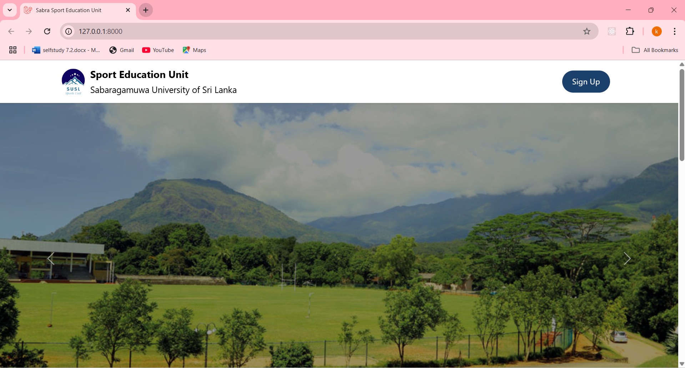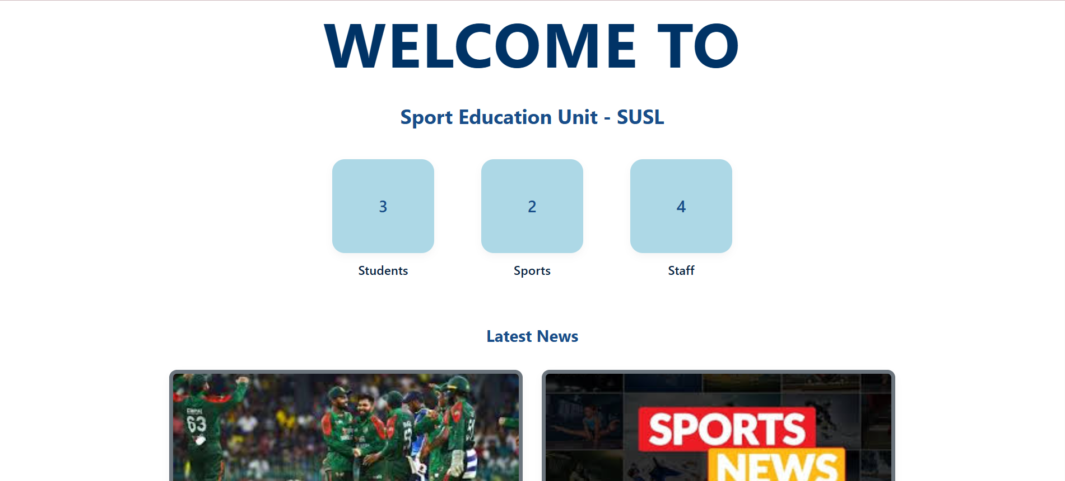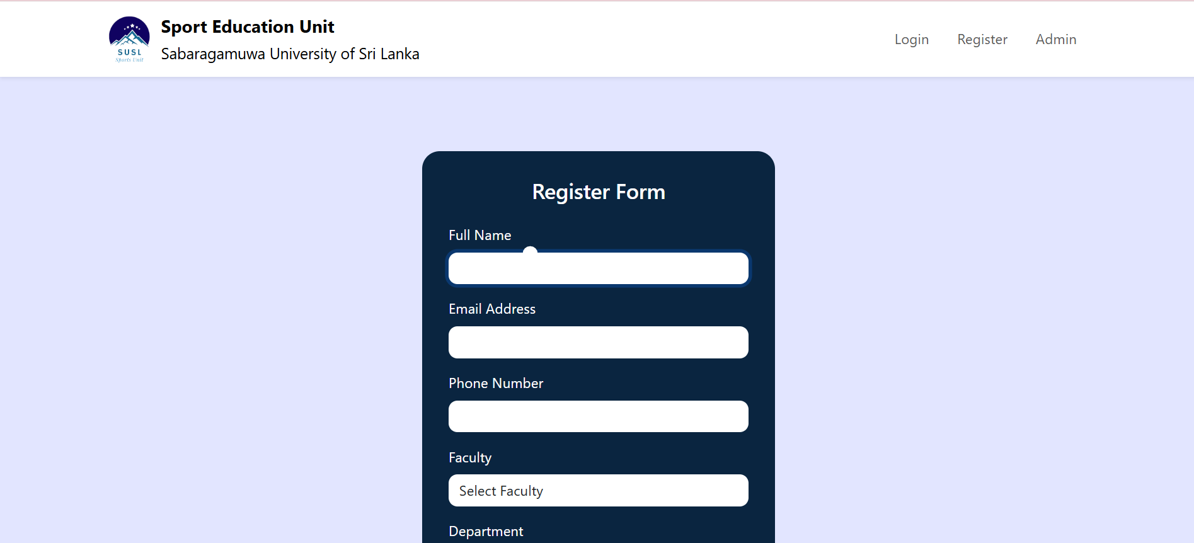

#### Security

Security is a key priority of the system. User authentication is enforced with secure login credentials and session-based access control, preventing unauthorized access to sensitive data such as team rosters and user profiles. Passwords are encrypted using hashing algorithms and are not stored in plain text. Admin functionalities are access-restricted based on role-based authorization. The system prevents unauthorized CRUD operations through backend validation and route protection.

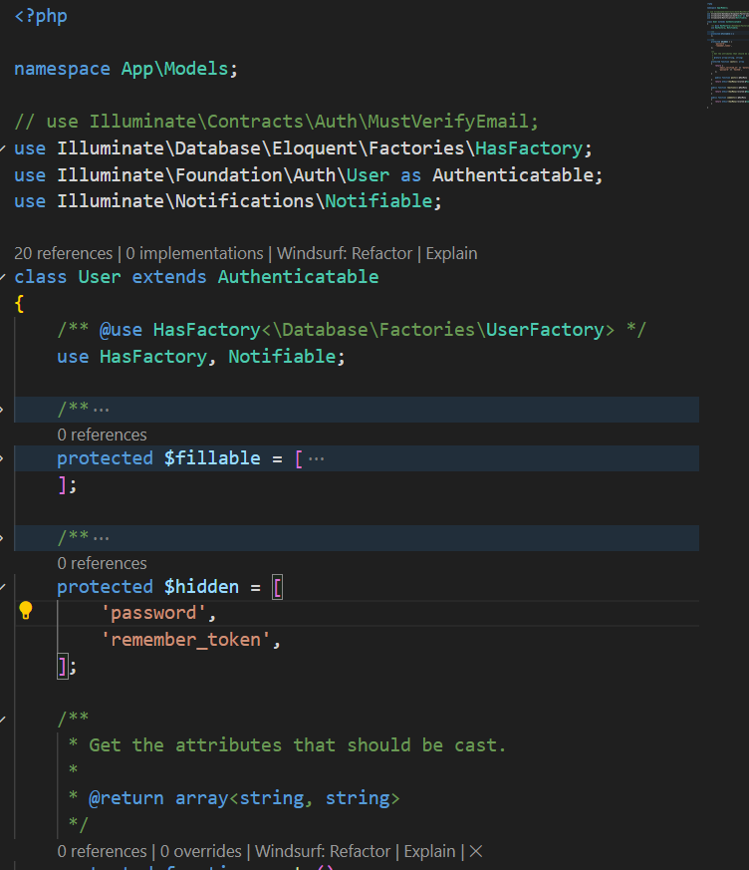

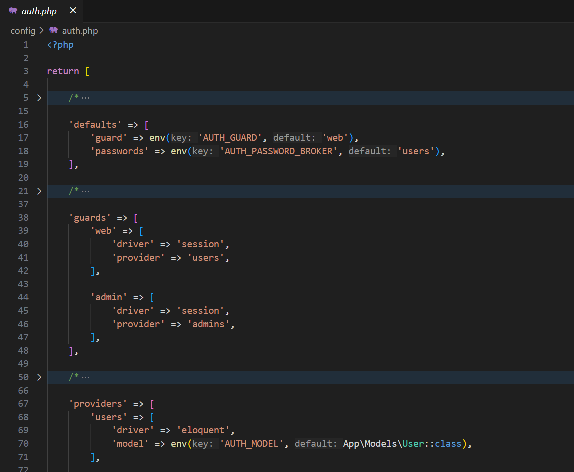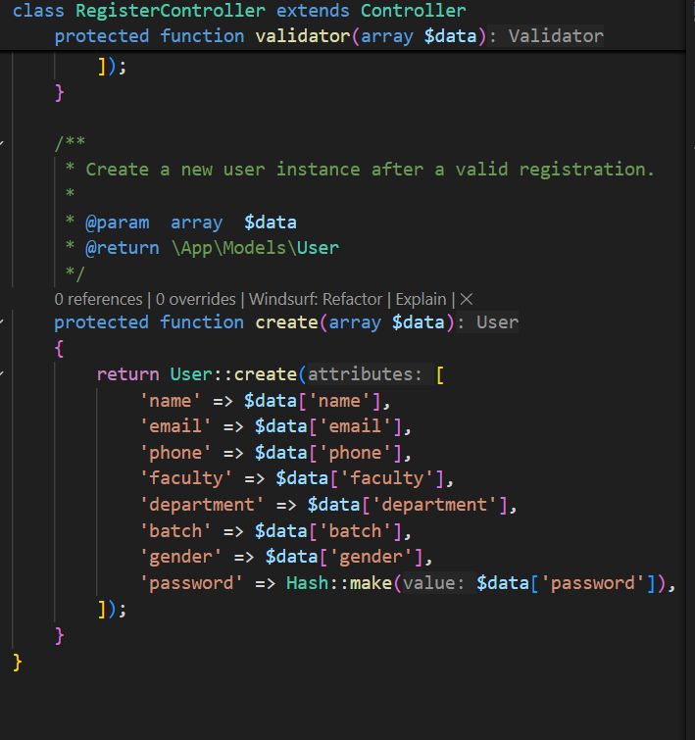

###### Scalability

The system is built on a scalable Laravel framework, making it capable of handling an increasing number of users and data entries, including sports teams, members, posts, and products in the online store. Database design and optimized queries support the ability to scale as more departments, players, or tournaments are added. The modular architecture ensures that future upgrades, such as adding new sports or additional admin panels, can be done efficiently without overhauling the entire system.

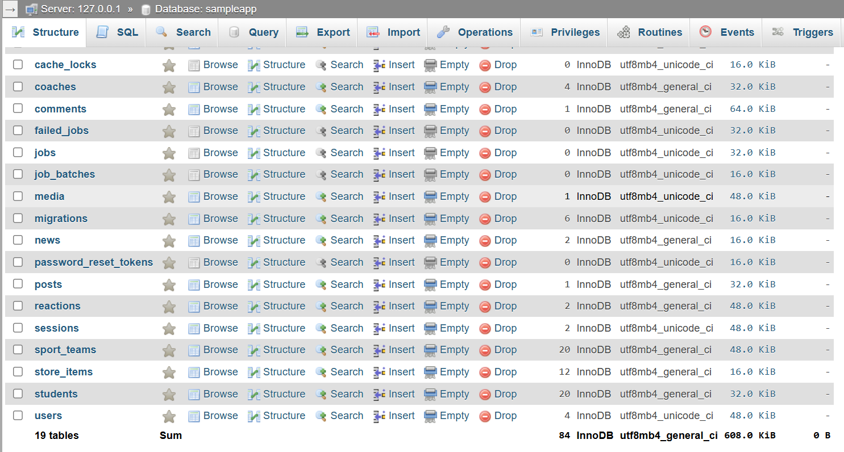

###### Performance

Performance has been optimized to ensure smooth user interactions. Page loads are minimized through efficient routing and use of Laravel Blade templating. Redundant data fetches are avoided using query optimization and pagination in team and product listings. The system responds swiftly to user actions such as searching, team registration, and content updates, even under moderate user loads.

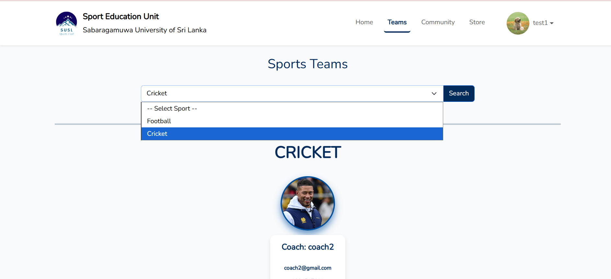

###### Reliability

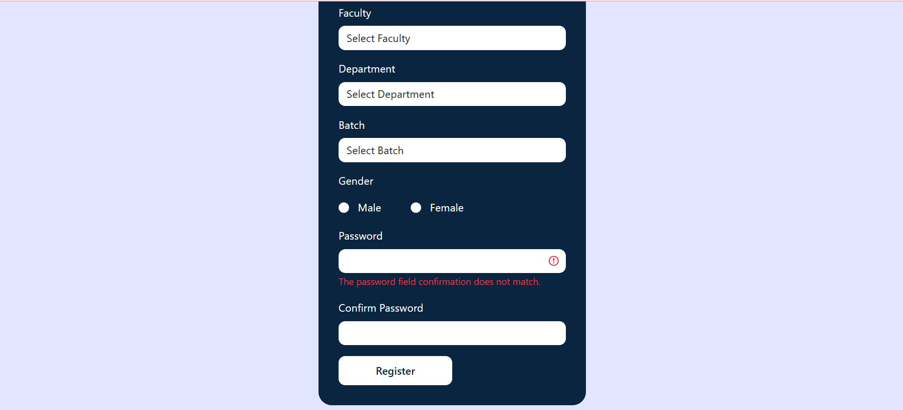The Sports Management System ensures reliable operation by validating all inputs, providing error messages, and maintaining data integrity across CRUD operations. Regular backups can be scheduled to prevent data loss. The system has been tested for common failure scenarios such as incorrect user input or broken links, with appropriate fallback mechanisms and friendly error pages implemented. Session handling ensures that users do not lose their work abruptly, providing a smooth and dependable experience.